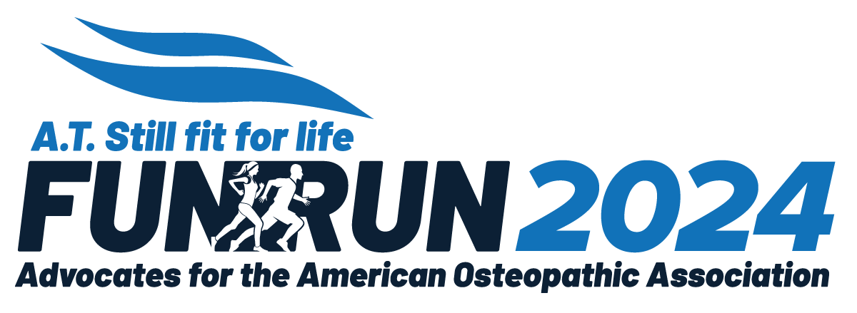

***A.T. Still fit or life Fun Run 2024***

***San Antonio, TX,***

***Sunday, September 22, 2024***

**CONTACT PERSON:**  ____________________________________________________________________

**PHONE:**  _______________________________      **EMAIL:**  ____________________________________

**ORGANIZATION NAME:**  __________________________________________________________________

**ADDRESS:**  _________________________________________________________________________

**CITY/STATE/ZIP:** ______________________________________________________________________

*Please indicate your organization’s contribution level below.   
All proceeds from the Fun Run will benefit the Advocates for the AOA (AAOA)Special Projects Grant Program.*

☐ **Starting Line Sponsor: $5,000**

The organization: will have their name/logo displayed on the Fun Run banner at OMED in large bold lettering, will have their sign cover the starting line and will have an individual sign on the course, will be promoted as a Starting Line Sponsor on the AAOA website and social media accounts, will have their name/logo located on the back of the run t-shirt at the top in large bold lettering, will have their name/logo on all flyers, may provide marketing materials to be included in the race packet, will receive 5 free Fun Run registrations and 5 additional t-shirts.

☐ **Registration Sponsor: $2,500**

The organization: will have their name/logo displayed on the Fun Run banner at OMED in large bold lettering, will be promoted as a Registration Sponsor on the AAOA website and social media accounts, will have their name/logo located on the back of the run t-shirt at the top in large bold lettering, will have their name/logo on an individual sign on the course, will have their name/logo on all flyers, may provide marketing materials to be included in the run packet, will receive 2 free Fun Run registrations and 4 additional t-shirts.

☐ **Course Sponsor: $1,500**

The organization: will have their name/logo displayed on the Fun Run banner at OMED, will be promoted as a Course Sponsor on the AAOA website and social media accounts, will have their name/logo located on the back of the run t-shirt, will have their name/logo on an individual sign on the course, will have their name/logo on all flyers, may provide marketing materials to be included in the run packet, will receive 2 free Fun Run registrations and 2 additional t-shirts for your organization

☐ **Fit Sponsor:  $1000**

The organization: will have their name/logo displayed on the Fun Run banner at OMED, will be promoted as a Fit Sponsor on the AAOA website and social media accounts, will have their name/logo located on the back of the run t-shirt, will have their name/logo on all flyers, may provide marketing materials to be included in the Fun Run packet.

☐ **Healthy Sponsor:  $500**

The organization: will have their name/logo displayed on the Fun Run Banner at OMED, will be promoted as a Healthy Sponsor on the AAOA website and social media accounts, will have their name/logo located on the back of the run t-shirt, may provide marketing materials to be included in the Fun Run packet

☐ **Pace Setter Sponsor:  $250**

The organization: will have their name/logo displayed on the Fun Run banner at OMED, will be promoted as a Pace Setter sponsor on the AAOA website and social media accounts, may provide marketing materials to be included in the Fun Run packet

☐ **Team Sponsor:** **$25 - $150 (select your donation amount)**

The organization will sponsor a team of runners. Will be listed as a team sponsor on the AAOA website and social media accounts.

*Please send your* ***completed form*** *with the following* ***no later than August 1, 2024:***

* ***Contribution*** *- paid online at* [*https://www.advocates4dos.org/store/fun-run-sponsorship*](https://www.advocates4dos.org/store/fun-run-sponsorship) *or*

*by check made payable to AAOA - mailed to address below.*

* ***Race packet materials*** *(for 100 participants) - mailed to the address below.*
* ***Camera-ready logo*** *(PNG or JPEG) - emailed to* [*advocates@advocates4dos.org*](mailto:advocates@advocates4dos.org)

*Mailing Address:*

***A.T. Still Fit for Life Fun Run****,* c/o AAOA

142 E. Ontario Street

Chicago, IL  60611

**For more information contact**

Caryn Tabby, AAOA Fun Run Chair, at [caryn.tabby@gmail.com](mailto:caryn.tabby@gmail.com) or you may reach out to Hope Hurley, AAOA Executive Director, at [hhurley@osteopathic.org](mailto:hhurley@osteopathic.org) or call (312) 202-8076.

Thank you for your support!